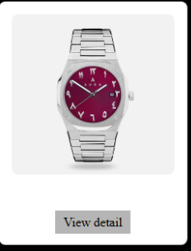

**Product Name: Royal Maroon Arabic Dial Watch**

**Description:**

Make a bold statement with the Royal Maroon Arabic Dial Watch — a refined blend of Arabic heritage and contemporary elegance. The rich maroon dial features striking Eastern Arabic numerals, delivering a unique aesthetic that captures attention. Paired with a robust stainless steel bracelet, this watch is perfect for those who appreciate culture, precision, and high-end design.

**Specifications:**

* **Brand:** Noura
* **Model Number:** NA-W002
* **Dial Color:** Maroon
* **Numerals:** Eastern Arabic numerals
* **Case Material:** Stainless Steel
* **Strap Material:** Stainless Steel
* **Movement:** Quartz
* **Case Size:** 42 mm
* **Glass:** Mineral Crystal
* **Water Resistance:** 3 ATM (splash resistant)
* **Clasp Type:** Fold-over clasp
* **Warranty:** 1-Year Manufacturer Warranty

**Price:**

**$259.00 USD**